Assignment 5

Sachin Shubham

3/5/2021

Task 1

A study was done to compare soil mapping units on the basis of their lateral variability’s for a single property, silt content. The study area consisted of a sequence of eight contiguous sites extending over the crest and flank of a low rise in a valley plain underlain by marl near Albudeite in the province of Murcia, Spain. The geomorphological sites were the primary mapping units adopted and were small areas of ground surface of uniform shape. Following the delimination of the sites, soil samples were obtained in each site at 11 random points within a 10mx10m area centered on the midpoint of the site. All samples were taken from the same depth. The soil property considered was the silt content, expressed as percentages of the total silt, clay and, sand content. The data are given in SiltDataset.csv

setwd('D:/Statistical Methods/Assignments/Assignment 5')  
siltData <- read.csv("SiltDataset.csv")  
#Factor  
siteFactor <- factor(siltData$site)  
#ANOVA  
analysis <- aov(siltData$silt ~ siteFactor)  
#Summary  
summary(analysis)

## Df Sum Sq Mean Sq F value Pr(>F)   
## siteFactor 7 600.1 85.73 3.432 0.00293 **  
## Residuals 80 1998.4 24.98   
## ---  
## Signif. codes: 0 '***' 0.001 '**' 0.01 '*' 0.05 '.' 0.1 ' ' 1

#Boxplot  
bPlot<-boxplot(siltData$silt~siteFactor,xlab="Site",  
 ylab="Silt",  
 border = par("fg"), col = "bisque", log = "",  
 main="Boxplots of Site vs Silt")  
means <- tapply(siltData$silt, siteFactor, mean)  
points( means, pch=8, col="blue")

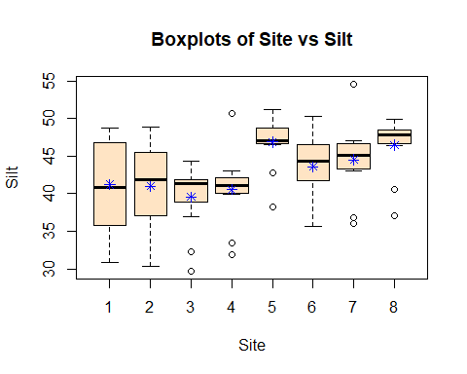 Since the p-value (0.00293 < 0.05) is less than 0.05, the difference in means is statistically significant. Therefore, there is difference in silt content among the soils from different sites.